**Insurance Premium Prediction**

***Wireframe Documentation***



**Project On**

**Insurance Premium Prediction**

**By:- Subhash Dixit (iNeuron)**

**Date:- 07/01/2022**

***Landing Page:***

***This is the landing page where the user/policyholder is allowed rather to put inputs on the parameters shown in order to get a rough idea about the premium for a given set of conditions.***

***As soon as the user/policyholder hits the Show Result button, the premium gets displayed based on the conditions given.***

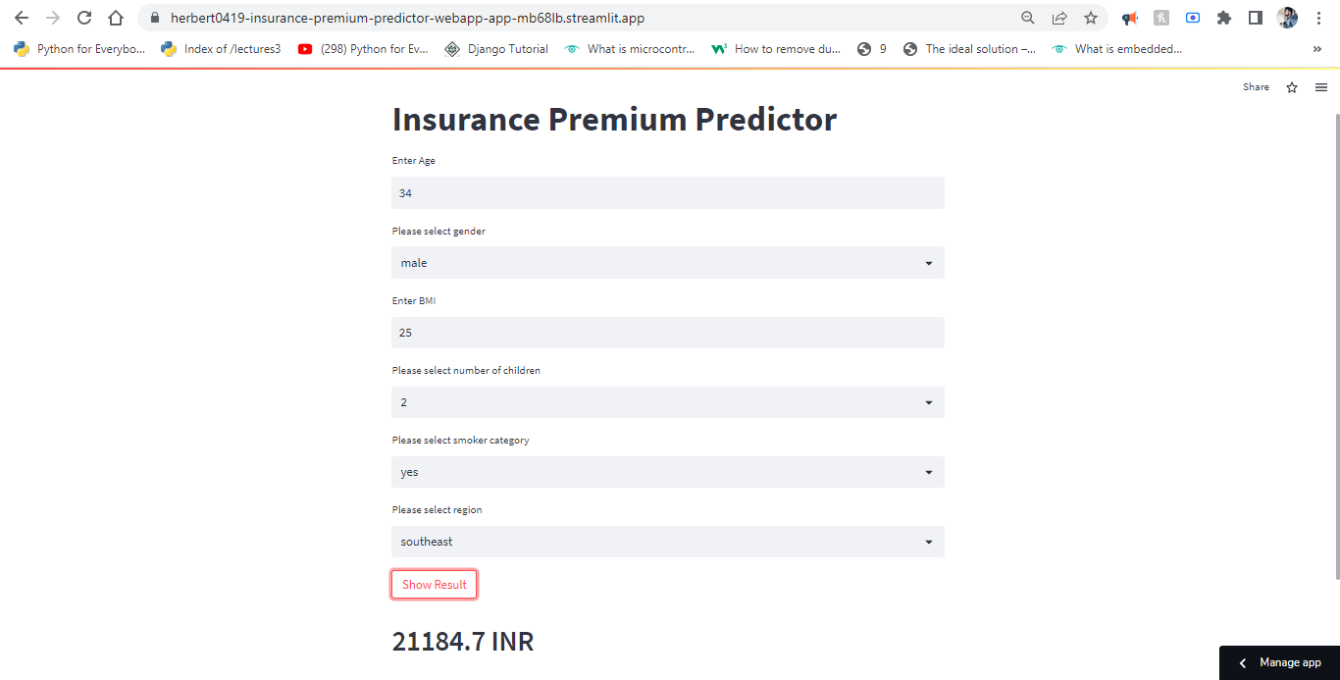

**WebApp link**: [*https://subhashdixit-insurance-prediction-app-t93foa.streamlit.app/*](https://github.com/subhashdixit/Insurance_Premium_Predictor_WebApp)